CSC 300 - Week 3 Project Deliverable
Smart Refrigerator Display System
Team Member 1: John (Karl) Dusenbery

Actor-System Interaction Model of Top 3 Use Cases:
UC1 - ADD FOOD ITEM TO INVENTORY
Precondition: User must be at the main menu screen
Actor: User | System: Smart Refrigerator Display (SRD)
 | 0. System displays main menu with options: Inventory, Temperature Control, Meal Planning
1. TUCBW user taps 'Inventory' button on touchscreen
 | 2. System displays inventory menu with options: View Items, Add Item, Remove Item
3. User selects 'Add Item'
 | 4. System displays item entry dialogue box with options: a.) Manual Entry b.) Barcode Entry
5. User selects: a.) Manual Entry, or
b.) Barcode Entry
 | 6. System accordingly displays: a.) Virtual keyboard for product name entry, or b.) Numeric keypad for barcode number entry
7. User accordingly: a.) Types product name (e.g., 'Milk'), or b.) Enters barcode number
 | 8. System validates entry and displays: - Product confirmation - Quantity entry keypad (0-9)
9. User enters quantity and presses 'Enter'
 | 10. System displays expiration date entry with calendar picker
11. User selects expiration date
 | 12. System displays refrigerator zone selection with blueprint view showing: - Main compartment - Freezer - Crisper drawer - Door shelves
13. User taps desired storage zone
 | 14. System saves item to inventory database and displays confirmation message: 'Item Added Successfully'
 | 15. TUCEW system returns to inventory menu
Postcondition: Food items are stored in system inventory with name, quantity, expiration date, and zone location.
UC2 - VIEW CURRENT INVENTORY
Precondition: System has at least one item in inventory
Actor: User | System: Smart Refrigerator Display (SRD)
 | 0. System displays main menu
1. TUCBW user taps 'Inventory' button
 | 2. System displays inventory menu with View Items option
3. User selects 'View Items'
4. System displays view options dialogue:
a.) View by Zone
b.) View as List
5. User selects:
a.) By Zone, or
b.) As List
6. System accordingly displays:
a.) Blueprint view with clickable zones, or
b.) Complete inventory list
7a. IF By Zone selected: User clicks a specific zone
 | 8a. System displays items in selected zone: - Item name - Quantity - Expiration date - Days until expiration (highlighted if <3 days)
7b. ELSE IF List selected: User views complete list
 | 8b. System displays all items alphabetically: - Item name - Quantity - Expiration date - Storage zone - Days until expiration
9. User can:
a.) Select an item for details
b.) Press 'Back' to return
10. System accordingly:
a.) Shows item detail screen with edit/remove options b.) TUCEW returns to inventory menu

Postcondition: User has viewed inventory items; no data changes occurred.
Alternative Flow: If inventory is empty, system displays 'No items in inventory. Would you like to add items?' with Yes/No options.
UC3 - CHECK/ADJUST TEMPERATURE SETTINGS
Precondition: System is powered on and temperature sensors are functional.
Actor: User | System: Smart Refrigerator Display (SRD)
 | 0. System displays main menu
1. TUCBW user taps 'Temperature Control'
 | 2. System displays blueprint view of refrigerator with zones: - Main compartment: 37°F - Freezer: 0°F - Crisper: 39°F - Each zone shows current temperature
3. User taps a specific zone
 | 4. System displays temperature adjustment screen: - Current temperature (large display) - Slider control (min to max range) - Numeric display of selected temp - C/F toggle button
5. User adjusts temperature by:
a.) Moving slider, or
b.) Tapping numeric display for keypad entry
6. System accordingly:
a.) Updates display as slider moves, or
b.) Shows numeric keypad (0-9, decimal point)
7. User confirms new temperature setting
 | 8. System validates temperature: - Main: 34-44°F range - Freezer: -5 to 5°F range - Crisper: 32-42°F range
 | 9. IF temperature valid: System applies new setting and shows 'Temperature Updated' ELSE: System shows 'Invalid Temperature Range' with valid range
10. User can:
a.) Adjust another zone
b.) Toggle C/F display
c.) Press 'Back'
11. System accordingly:
a.) Returns to zone selection
b.) Converts all displays to Celsius/Fahrenheit
c.) TUCEW returns to main menu
 | 12. System logs temperature change in history
Postcondition: Temperature settings are updated and actively controlling refrigerator zones.
Exception Flow: If temperature sensor fails, system displays 'Sensor Error - Please Contact Service' and disables adjustment for that zone.
Business Rule: System prevents unsafe temperature settings that could cause food spoilage or excessive energy consumption.

CSC 300 - Week 3 Project Deliverable - Week 1/2 changes
UML Class Diagram with attributes, operations, relationships
Team Member 2: Vincent Hernandez
Key changes:
- SystemController acts as primary coordinator.
- Display handles all UI interactions.
- MealPlanner depends on RecipeDatabase for lookup.
- InventoryManager manages food recognition (camera) and manual entries.
- UserSettings stores communication preferences and temperature units.

Class Diagram:
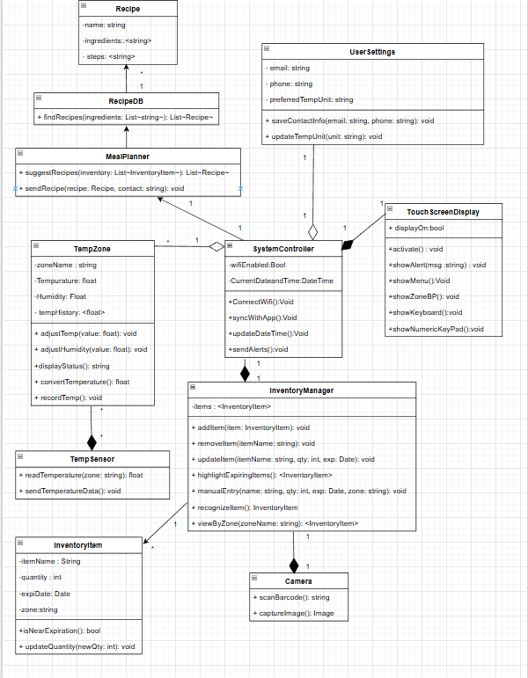

CSC 300 - Week 3 Project Deliverable
Domain Model - Domain Model Description
Team Member 3: Gabby Luna

Domain Model Figure
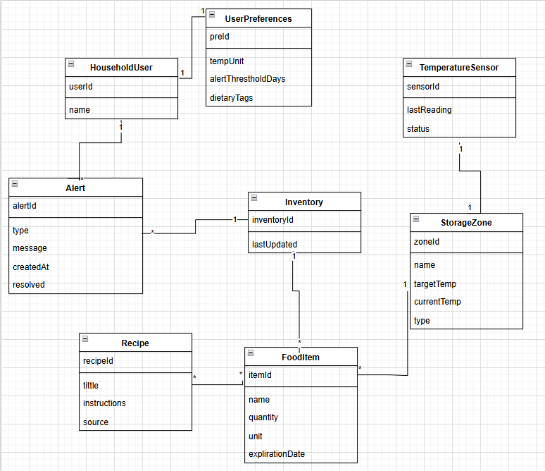

Domain Model Description: Smart Refrigerator Display System
The Domain Model for the Smart Refrigerator Display System captures the main concepts involved in tracking and managing food inside a smart fridge. A HouseholdUser interacts with the system and has exactly one associated UserPreferences object, which stores configuration such as temperature units, alert threshold days, and dietary tags. Users can receive multiple Alert objects, for example: expiration alerts or temperature alerts, and alerts are also associated with the Inventory since many alerts are triggered by the current inventory state.
The Inventory represents the collection of all items currently stored in the refrigerator. It contains many FoodItem objects, each with an ID, name, quantity, unit, and expiration date. Each FoodItem is stored in exactly one StorageZone, while each StorageZone can contain many items. Storage zones model the physical compartments of the fridge such as refrigerator shelves or freezer drawers, and include attributes for name, target temperature, current temperature, and type. Each StorageZone is monitored by a single TemperatureSensor, which reports its most recent reading and status.
The model also includes Recipe as a separate concept. A Recipe can reference many FoodItem instances as ingredients, and a single food item can be used in multiple recipes, resulting in a many-to-many association. Overall, the Domain Model focuses on the real-world entities such as users, items, zones, sensors, alerts, recipes, and inventory, and their relationships, without including UI or controller classes.

